1.What are the two values of the Boolean data type? How do you write them?

**Answer** :

True and False are two values of Boolean data type. We write them using capital T and F and rest in lowercase.

2. What are the three different types of Boolean operators?

**Answer:**

AND, OR, NOT are three different Boolean operators.

3. Make a list of each Boolean operator’s truth tables (i.e. every possible combination of Boolean

values for the operator and what it evaluate.)

**Answer:**

1. AND

|  |  |  |
| --- | --- | --- |
| True | True | True |
| True | False | False |
| False | True | False |
| False | False | False |

1. OR

|  |  |  |
| --- | --- | --- |
| True | True | True |
| True | False | True |
| False | True | True |
| False | False | False |

1. NOT

|  |  |
| --- | --- |
| True | False |
| False | True |

4. What are the values of the following expressions?

(5 > 4) and (3 == 5) => False

not (5 > 4) => False

(5 > 4) or (3 == 5) => True

not ((5 > 4) or (3 == 5)) => False

(True and True) and (True == False) => False

(not False) or (not True) => True

5. What are the six comparison operators?

**Answer :**

1. Greater than (>)
2. Less than (<)
3. Greater than equal to (>=)
4. Less than equal to (<=)
5. Equal to (==)
6. Not equal to (!=)

6. How do you tell the difference between the equal to and assignment operators? Describe a

condition and when you would use one.

**Answer:**

Equal to (==) is the operator that compares two values and gives Boolean result, while assignment (=) operator stores the value to a variable.

Examples/condition:

Assignment operation for assigning a value => x=”Hello, World!” , a=10, etc

Equal to (==) to compare => 5==6 which will give False(0) , 6==6 which gives True(1)

7. Identify the three blocks in this code:

spam = 0

if spam == 10:

print(‘eggs’)

if spam > 5:

print(’bacon’)

else:

print(‘ham’)

print(‘spam’)

print(‘spam’)

**Answer:**

The three blocks are – everything inside the if statement and the lines – print(‘bacon’) and print(‘spam’)

if spam == 10:

print(‘ham’)

print(‘eggs’)

if spam > 5:

print(’bacon’)

else:

print(‘ham’)

print(‘spam’)

print(‘spam’)

8. Write code that prints Hello if 1 is stored in spam, prints Howdy if 2 is stored in spam, and prints

Greetings! if anything else is stored in spam.

**Answer :**

spam=10

if(spam==1):

print("Hello")

elif(spam==2):

print("Howdy")

else:

print("Greetings")

Output => Greetings

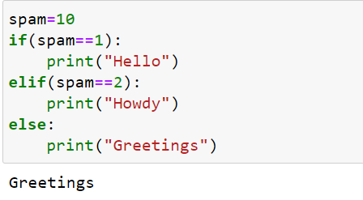

9.If your programme is stuck in an endless loop, what keys you’ll press?

**Answer :**

Press Ctrl + C if program is stuck in infinite loop

10. How can you tell the difference between break and continue?

**Answer:**

Break statement stops the entire process of the loop while continue statement only stops the current iteration of the loop.

11. In a for loop, what is the difference between range(10), range(0, 10), and range(0, 10, 1)?

**Answer :**

They all give the same result.

range(10) – It tells that range starts from 0 till 10(excluding 10)

range(0,10) – It explicitly tells that range starts from 0 to 10(excluding 10)

range(0,10,1) – It denotes that range increases by 1 for each iteration.

12. Write a short program that prints the numbers 1 to 10 using a for loop. Then write an equivalent

program that prints the numbers 1 to 10 using a while loop.

**Answer :**

**FOR =>**

for i in range(1,11):

print(i)

**WHILE =>**

i=1

while (i<=10):

print(i)

i=i+1

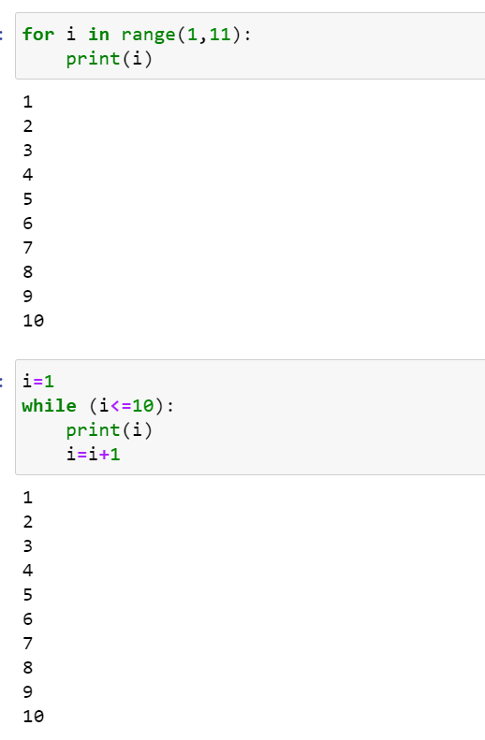

13. If you had a function named bacon() inside a module named spam, how would you call it after

importing spam?

**Answer:**

spam.bacon()